International Conference on Baptist Studies X

Baptists and Education

Westminster College, Cambridge

Wednesday 7 August – Saturday 10 August 2024

International Conferences on Baptist Studies have been held on a three-yearly basis since the first, hosted by Regent’s Park College, Oxford, in 1997. They have taken place at institutions in Australia, Canada, the Czech Republic, England and the United States. Although the ninth had to be cancelled because of complications following Covid, papers that were due to be delivered then will be published in 2023 by Mercer University Press. The tenth in the series is to be held in August 2024 at Westminster College, Cambridge. All the conferences take the history of the Baptists from their beginnings until the present day as their subject matter but are not restricted to Baptists as speakers or attenders. The theme this time is ‘Baptists and Education’, which includes popular schooling, private institutions, higher education, catechetical work, published literature and training for the ministry. What has been the Baptist contribution to education in different lands at various times? The theme will be considered by case studies, some of which will be very specific in time and place while others will cover long periods and more than one country.

A number of main speakers will address many aspects of the subject, but offers of short papers to last no more than 25 minutes in delivery are welcome. They should relate in some way to ‘Baptists and Education’. The proposed title should be submitted to Professor David Bebbington, Emeritus Professor of History at the University of Stirling, by e-mail at d.w.bebbington@stir.ac.uk. We are planning that, as in the past, a volume containing many of the conference papers will appear in print.

Westminster College is a theological college of the United Reformed Church. Full-board accommodation will be provided in its attractive buildings near the centre of Cambridge for the three days from after lunch on Wednesday 7 August to lunchtime on Saturday 10 August 2024. That will include an ensuite room, breakfast, lunch, dinner and snacks each day as well as use of the college’s facilities including a common room and the chapel. Arrangements can be made for an extra charge to add lunch on Wednesday 7, arrival on Tuesday 6 and/or staying on until Sunday 11. A non-refundable deposit will be needed at the time of booking and full payment will be required by 30 June 2024. Bookings, using the form below, can now be made to the Tutorial Office Manager, Syd Harper, at tutorial@westminster.cam.ac.uk. She will also be pleased to answer enquiries.

It will be possible during the conference to visit some of the historic colleges of the university, which are within easy walking distance. The Cambridge Centre for World Christianity, which holds an extensive library on its subject, is housed in Westminster College and will be accessible to conference attenders. We look forward to a stimulating occasion.

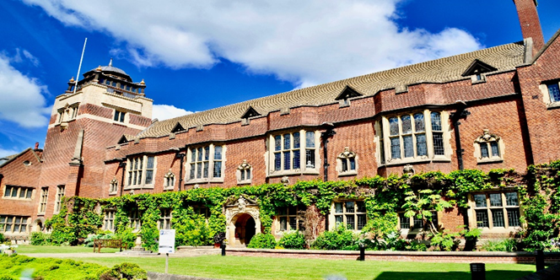

International Conference on Baptist Studies X
Wednesday 7th to Saturday 10th August 2024 Booking Form
(please complete and return this page to the Tutorial Office with advice of deposit or full payment)

Name (inc. title) | Click or tap here to enter text.
Address | Click or tap here to enter text.
Tel/Mobile | Click or tap here to enter text.
Email address | Click or tap here to enter text.
Affiliation (if any) | Click or tap here to enter text.
Please tick as required:
Please tick | Requirements | Cost | Office use
☐ | Ensuite room with meals (Wednesday from 2pm arrival to Saturday lunchtime) | £459.00
☐ | Ensuite room with meals, two days only (please indicate which) | £306.00
☐ | Ensuite room with meals, one night (please indicate which) | £153.00
☐ | Day visitor (lunch, dinner, tea and coffee – Wednesday to Saturday lunch) | £ 99.50
☐ | Day visitor (lunch, dinner, tea and coffee – two days Thursday and Friday) | £ 56.00
☐ | Day visitor (lunch, dinner, tea and coffee – one day – please indicate which) | £ 28.00
☐ | Day visitor (dinner only, Wednesday) | £ 13.50
☐ | Day visitor (lunch only, Saturday) | £ 11.50
☐ | Additional lunch, Wednesday | £ 11.50
☐ | Overnight accommodation, Tuesday 6th August | £ 93.00
☐ | Overnight accommodation, Saturday 10th August | £ 93.00
Special Meal Requirements
We can accommodate dietary needs and requirements, but as our kitchen cooks ‘to order’, we need to know in advance. Please let us know any requirements or allergies below:
Other Requirements
Please help us to make your visit more comfortable by listing any special requirements we should be aware of, e.g. accessibility needs.
Payment
Either a deposit (£50 for residential guests) or full payment is required at the time of submitting this form. Payments are preferred by electronic transfer. Please include ‘ICOBS [your last name, first initial] as the payment reference. Please note – rate of exchange to be applied prior to payment.
☐ | BACS payment to Sort Code: 30-91-56 Account No: 02076747  IBAN: GB47 LOYD 3091 5602 0767 47 BIC: LOYDGB21018  Name: Westminster College  Bank Address: Lloyds TSB, 3 Sidney Street, Cambridge | Payment  Amount | £
☐ | Please contact me to pay securely over the phone

For enquiries or queries, contact Tutorial Office, Westminster College, Madingley Road, Cambridge CB3 0AA
tutorial@westminster.cam.ac.uk /+44 1223 33 06 49
Please return by email to:
Tutorial Office – tutorial@westminster.cam.ac.uk

Signed :
Date:

